Chapter 2
1. If a binary signal is sent over a 3-kHz channel whose signal-to-noise ratio is 20 dB, what is the maximum achievable data rate?
Nyquist 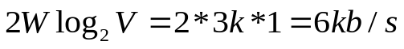
Shannon 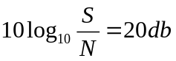 so, 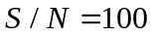
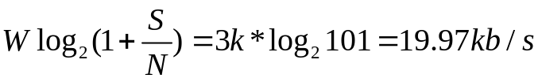
So, the maximum achievable data rate is 6kb/s

2. What signal-to-noise ratio is needed to put a T1 carrier on a 50-kHz line?
The data-rate in T1 is 1.544 Mb/s
So, 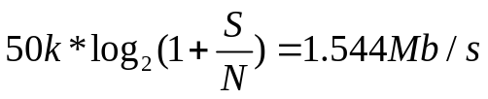
Solve it can get signal-to-noise ratio is

3. Ten signals, each requiring 4000 Hz, are multiplexed on to a signal channel using FDM. How much minimum bandwidth is required for the multiplexed channel? Assume that the guard bands are 400 Hz wide.

Chapter 3
1. A bit string, 0111101111101111110, needs to be transmitted at the data link layer. What is the string actually transmitted after bit stuffing?
A 0 needs to be inserted after every 5 consecutive 1's
011110111110011111010

2. What is the remainder obtained by dividing x^7 + x^5+1 by the generator polynomial x^3 +1 ? (注：x^7表示x的7次方，其它表述方式相同)
x^7 + x^5+1  10100001
x^3 +1 1001
10100001 divided by 1001 the remainder is 111
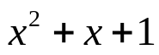

3 Data link protocols almost always put the CRC in a trailer rather than in a header. Why?
In the process of data transmission, the Cyclic Redundancy Check (CRC) is calculated and added to the output stream immediately after the final bit is transmitted. If the CRC were positioned in the header, it would require a complete pass over the frame to calculate the CRC prior to transmission. This would mean that each byte would have to be processed twice—first for the purpose of checksumming and then for transmission. Placing the CRC in the trailer effectively reduces the workload by half.
4. Frames of 1000 bits are sent over a 1-Mbps channel using a geostationary satellite whose propagation time from the earth is 270 msec. Acknowledgements are always piggybacked onto data frames. The headers are very short. Three-bit sequence numbers are used. What is the maximum achievable channel utilization for
- (a) Stop-and-wait.
- (b) Protocol 5
- (c) Protocol 6
- Stop-and-wait.
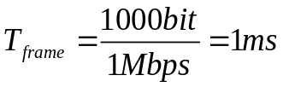， so 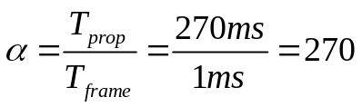
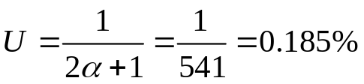
- Protocol 5(go-back-n protocol)
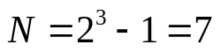, 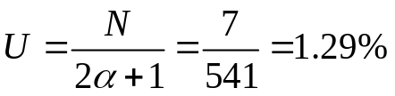
- Protocol 6(selective repeat protocol)
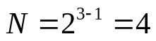, 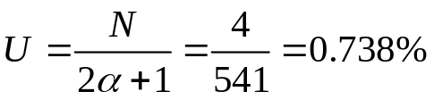

5. What is the minimum overhead to send an IP packet using PPP? Count only the overhead introduced by PPP itself, not the IP header overhead.
2 +1+2=5 bytes

